**Chapter 6 Photosynthesis**

**6-1 Light Reactions**

**6-2 Calvin Cycle**

**6-1 Objectives**

* **Explain** why almost all organisms depend on photosynthesis.
* **Describe** the role of chlorophylls and other pigments in photosynthesis.
* **Summarize** the main events of the light reactions.
* **Explain** how ATP is made during the light reactions.

**Obtaining Energy**

* **_______________________________** converts light energy from the sun into chemical energy in the form of organic compounds through a series of reactions known as **_______________________________**.
* Complex series of chemical reactions in which the product of one reaction is consumed in the next reaction.

**Obtaining Energy**

* **_______________________________** use energy from sunlight or from chemical bonds in inorganic substances to make organic compounds.
* Producers
* Photosynthetic organisms
* **_______________________________** organisms
* Animals and other organisms that must get energy from food instead of directly from sunlight or inorganic substances are called **_______________________________.**
* Consumers
* Primary consumers
* Secondary consumers
* **_______________________________**

**Overview of Photosynthesis**

* The oxygen (O2) and some of the organic compounds produced by photosynthesis are used by cells in a process called **_______________________________**.

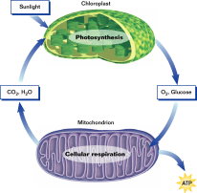

**Overview of Photosynthesis**

* Photosynthesis can be divided into two stages: **____________________**and *Calvin Cycle*
* In the **_______________________________**, light energy is converted to chemical energy, which is temporarily stored in ATP and the energy carrier molecule NADPH.
* In the *Calvin Cycle*, organic compounds are formed using CO2 and the chemical energy stored in ATP and NADPH.

**Overview of Photosynthesis**

* **Equation of Photosynthesis**

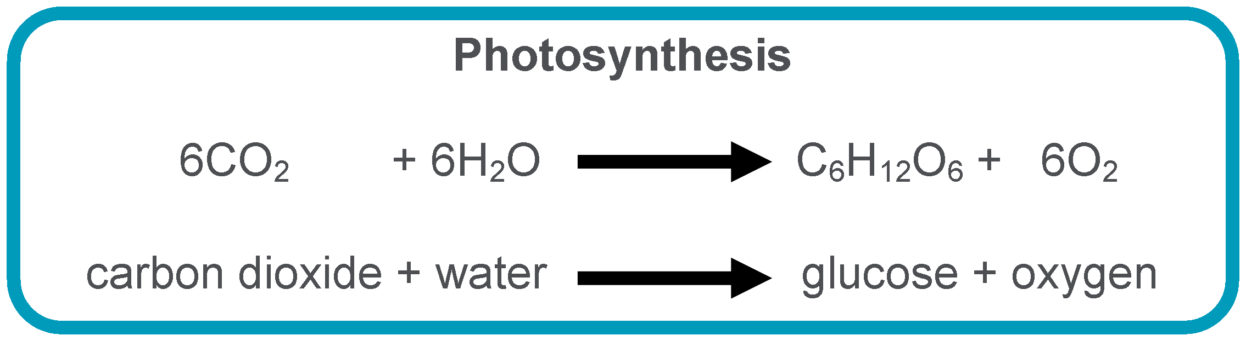

**Capturing Light Energy**

* The light reactions begin with the absorption of light in **_______________________________**, organelles found in the cells of plants, some bacteria, and algae.

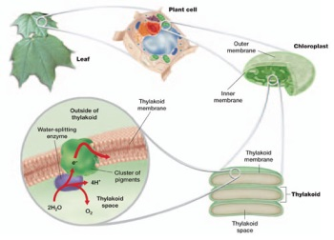

**Capturing Light Energy**

* Chloroplasts are surrounded by two membranes
* Inner and outer
* **_______________________________** are found inside the inner membrane
* Flattened sacs
* Thylakoids are connected and layered to form stacks called **_______________________________** (singular granum)
* Surrounding the grana is a solution called **_______________________________**

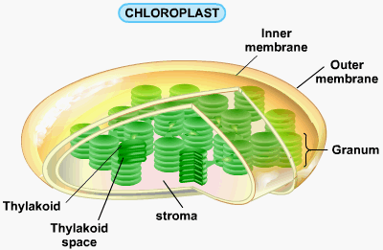

**Capturing Light Energy**

* **Light and Pigments**
* White light from the sun is composed of an array of colors called the *visible spectrum*.
* **_______________________________**

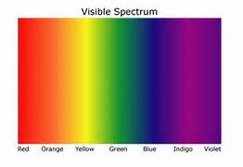

* **_______________________________** absorb certain colors of light and reflect or transmit the other colors.

**Capturing Light Energy**

* **Chloroplast Pigments**
* Located in the membrane of the thylakoids of chloroplasts are several pigments, including **_______________________________** (such as chlorophyll *a* and chlorophyll *b*) and **_______________________________**.

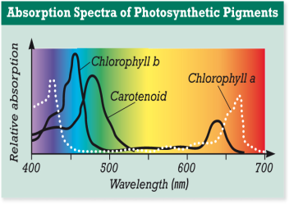

**Chloroplast Pigments**

* **_______________________________** absorbs less blue light but more red light than Chlorophyll *b* absorbs
* Neither chlorophyll *a* nor *b* absorbs much green light
* Allow green light to be reflected or transmitted
* Why plants containing larges amount of chlorophyll appear green.
* Only chlorophyll *a* is directly involved in the light reaction
* Chlorophyll *b* assists in capturing light and is therefore called an accessory pigment
* Carotenoids are yellow, orange, and brown
* **_______________________________**
* Allow plants to capture more of the energy in light

**Converting Light Energy to Chemical Energy**

* The pigments are grouped in clusters of a few hundred molecules in the thylakoid membrane. Each cluster and the proteins that the pigment molecules are embedded in are referred to collectively as a **_______________________________.**
* By absorbing light, pigment molecules in *photosystem I* and *photosystem II* acquire some of the energy carried by the light.

**Converting Light Energy to Chemical Energy**

* In each photosystem, the acquired energy is passed quickly to other pigment molecules until it reaches a specific pair of chlorophyll *a* molecules.
* The acquired energy forces electrons to enter a higher energy level in the two chlorophyll *a* molecules of photosystem II. These energized electrons are said to be “excited.” The excited electrons have enough energy to leave the chlorophyll *a* molecules.

**Converting Light Energy to Chemical Energy**

* The acceptor of these electrons from photosystem II is a molecule called the **_______________________________**, which donates the electrons to the **_______________________________.**
* As the electrons move from molecule to molecule in this chain, they lose most of the acquired energy. The energy they lose is used to move protons into the thylakoid.

**Light Reactions in Photosynthesis**

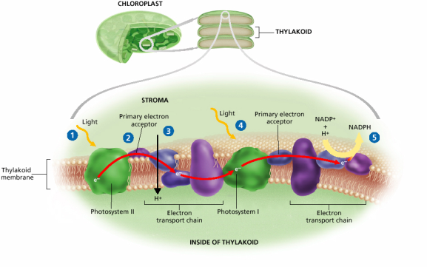

**Converting Light Energy to Chemical Energy**

* Light is absorbed by photosystem I at the same time it is absorbed by **_______________________________**. Electrons move from chlorophyll *a* molecules to another primary electron acceptor.
* The electrons lost from photosystem I are replaced by electrons that have passed through the electron transport chain from photosystem II.

**Converting Light Energy to Chemical Energy**

* These electrons are then donated to another electron transport chain, which brings the electrons to the side of the thylakoid membrane that faces the **_______________________________**.
* In the stroma, the electrons combine with a proton and NADP+. This causes NADP+ to be reduced to **_______________________________**.

**Converting Light Energy to Chemical Energy**

* **Replacing Electrons in Light Reactions**
* Electrons from **_______________________________**replace electrons that leave photosystem I. Replacement electrons for photosystem II are provided by the splitting of water molecules.
* Oxygen produced when water molecules are split diffuses out of the chloroplast and then   
  leaves the plant.

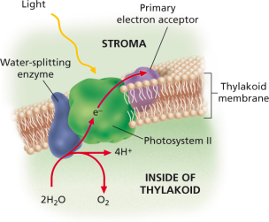

**Converting Light Energy to Chemical Energy**

* **Making ATP in Light Reactions**
* An important part of the light reactions is the synthesis of ATP. During **_______________________________**, the movement of protons through ATP synthase into the stroma releases energy, which is used to produce ATP.

**Summary of Processes in Light Reactions**

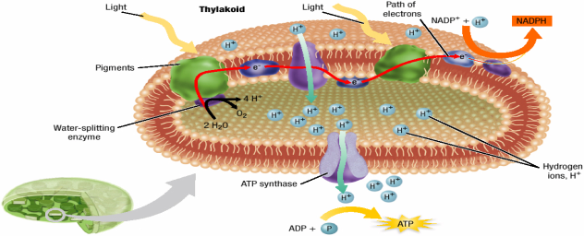

**6-2 Objectives – The Calvin Cycle**

* **Summarize** the main events of the Calvin cycle.
* **Describe** what happens to the compounds that are made in the Calvin cycle.
* **Distinguish** between C3, C4, and CAM plants.
* **Summarize** how the light reactions and the Calvin cycle work together to create the continuous cycle of photosynthesis.
* **Explain** how environmental factors influence photosynthesis.

**Carbon Fixation**

* The ATP and NADPH produced in the light reactions drive the second stage of photosynthesis, the **_______________________________**.
* In the Calvin cycle, CO2 is incorporated into organic compounds, a process called **_______________________________**.
* A total of **_______________________________**molecules must enter the Calvin cycle

**Carbon Fixation**

* The Calvin cycle, which occurs in the stroma of the chloroplast, is a series of enzyme-assisted chemical reactions that produces a **_______________________________**.
* Most of the three-carbon sugars (**___**) generated in the Calvin cycle are converted to a five-carbon sugar (**___________**) to keep the Calvin cycle operating. But some of the three-carbon sugars leave the Calvin cycle and are used to make organic compounds, in which energy is stored for later use.
* Plant species that fix carbon exclusively through the Calvin cycle are known as **_______________________________**

**Carbon Fixation**

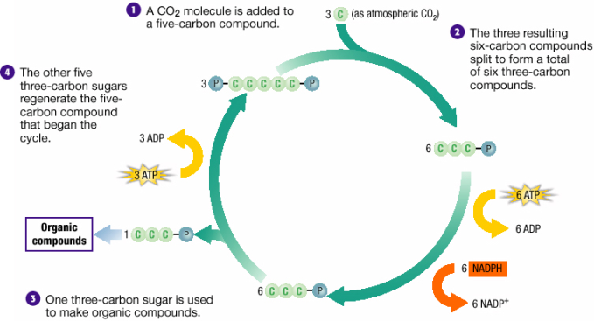

**Steps of Carbon Fixation**

1. Carbon dioxide diffuses into the stroma from the surrounding cytosol. Ribulose bisphosphate (RuBP) combines with each carbon dioxide molecule. Making a six carbon molecule that immediately splits into two 3 carbon molecules of 3-phosphoglycerate (3-PGA)
2. Each molecule of 3-PGA is converted into another 3 carbon molecule, glyceraldehyde 3-phosphate (G3P).
3. One G3P molecule leaves the Calvin cycle and is used to make organic compounds (carbohydrates) in which energy is stored for later use.
4. The other G3P molecules is converted back into RuBP through the addition of a phosphate group from ATP molecules. This RuBP enters the Calvin Cycle again.

**Alternative Pathways**

* **The C4 Pathway**
* Some plants that evolved in hot, dry climates fix carbon through the **_______________________________**. These plants have their stomata partially closed during the hottest part of the day.
* Certain cells in these plants have an enzyme that can fix CO2 into four-carbon compounds even when the CO2 level is low and the O2 level is high. These compounds are then transported to other cells, where the Calvin cycle ensues.

**Alternative Pathways**

* **The CAM Pathway**
* Some other plants that evolved in hot, dry climates fix carbon through the **_______________________________**. These plants carry out carbon fixation at night and the Calvin cycle during the day to minimize water loss.

**A Summary of Photosynthesis**

* Photosynthesis happens in two stages, both of which occur inside the chloroplasts.
* **_______________________________**-Energy is absorbed from sunlight and converted into chemical energy, which is temporarily stored in ATP and NADPH.
* **_______________________________**– Carbon dioxide and the chemical energy stored in ATP and NADPH are used to form organic compounds.

**A Summary of Photosynthesis**

* Photosynthesis is an **_______________________________**: the products of the light reaction are used in the Calvin cycle, and some of the products of the Calvin cycle are used in the light reactions.
* The other products of the Calvin cycle are used to produce a variety of organic compounds, such as amino acids, lipids, and carbohydrates.
* Extra carbohydrates are stored as starch in the chloroplasts and in structures such as **_______________________________**.
* These stored carbs provides the chemical energy that both autotrophs and heterotrophs depend on.

**Ongoing Cycle of Photosynthesis**

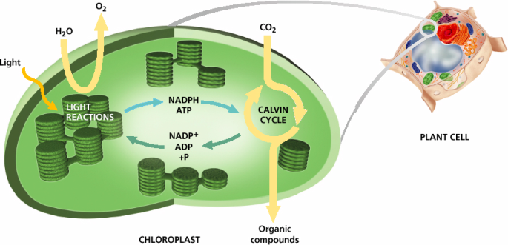

**A Summary of Photosynthesis**

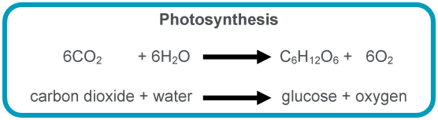

* Glucose is not actually a **_______________________________**of photosynthesis.
* It is used to emphasis the relationship between photosynthesis and cellular respiration.

**A Summary of Photosynthesis**

* The light reactions are sometimes referred to as **_______________________________**
* Because the energy from light is required for the reaction to occur.
* The Calvin cycle is sometimes referred to as the **_______________________________**or the **_______________________________**
* Because the Calvin cycle does not require light directly.
* Does not mean it occurs only at night. It usually occurs during the daytime, when the light reactions are working.

**Factors That Affect Photosynthesis**

* **Light Intensity**
* The rate of photosynthesis increases as **_______________________________**, because more electrons are excited in both photosystems.
* However, at some point all of the available electrons are excited, and the maximum rate of photosynthesis is reached. The rate then stays level regardless of further increases in light intensity.

**Factors That Affect Photosynthesis**

* **Carbon Dioxide Levels**
* As with increasing light intensity, **_______________________________**also stimulate photosynthesis until the rate levels off.

**Factors That Affect Photosynthesis**

* **Temperature**
* As **_______________________________**, the rate of photosynthesis increases to a maximum and then decreases with further rises in temperature.
* The rate peaks at a certain temperature, at which many of the enzymes that catalyze the reactions become ineffective. Also, the stomata begin to close, limiting water loss and entry of carbon dioxide.